NOME: RAFAEL FERNANDES MARQUES 4ºADS-A MANHÃ SOII

1) find . -group rfm
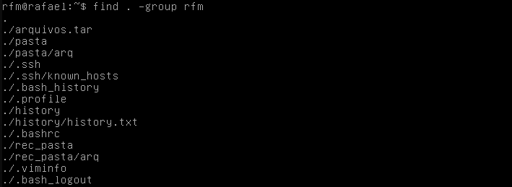
find . -group user1
find . -group user2

2) sudo updatedb

locate home/rfm/*/*.txt
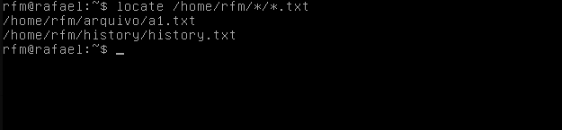
locate home/user1/*/*.txt

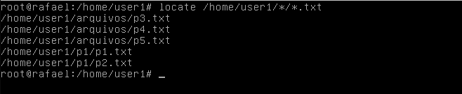

3) find /home/rfm/*/*.txt
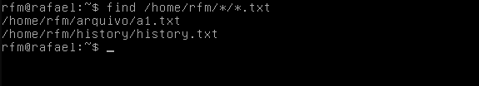

find /home/user1/*/*.txt
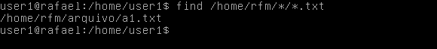

4) find – type d
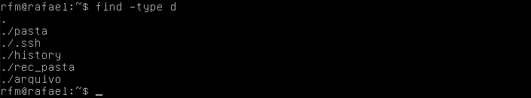

5) find . -type f -perm 777
find . -type f -perm 645
find . -type f -perm 654
find . -type f -perm 555

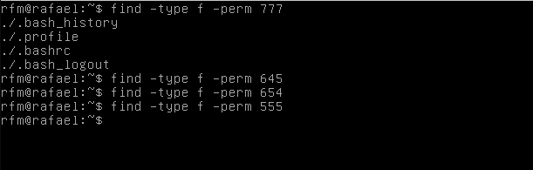

6) find . -type d -perm 777
find . -type d -perm 645
find . -type d -perm 654
find . -type d -perm 555
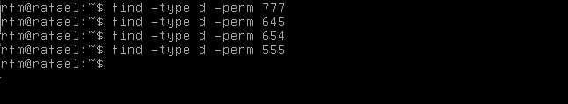

7) find / -perm /a=x

8) find / -perm /a-x

